A Patent Application For An Artificial Imagination

Peter Stott

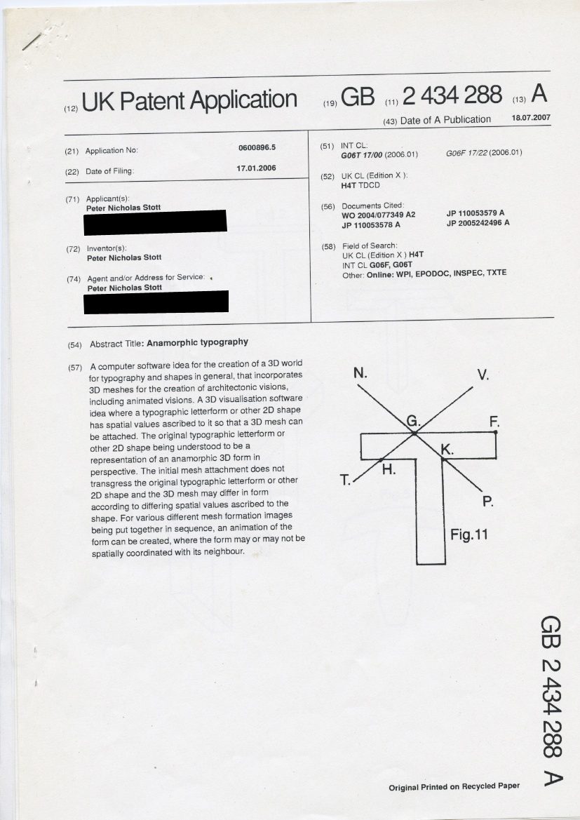

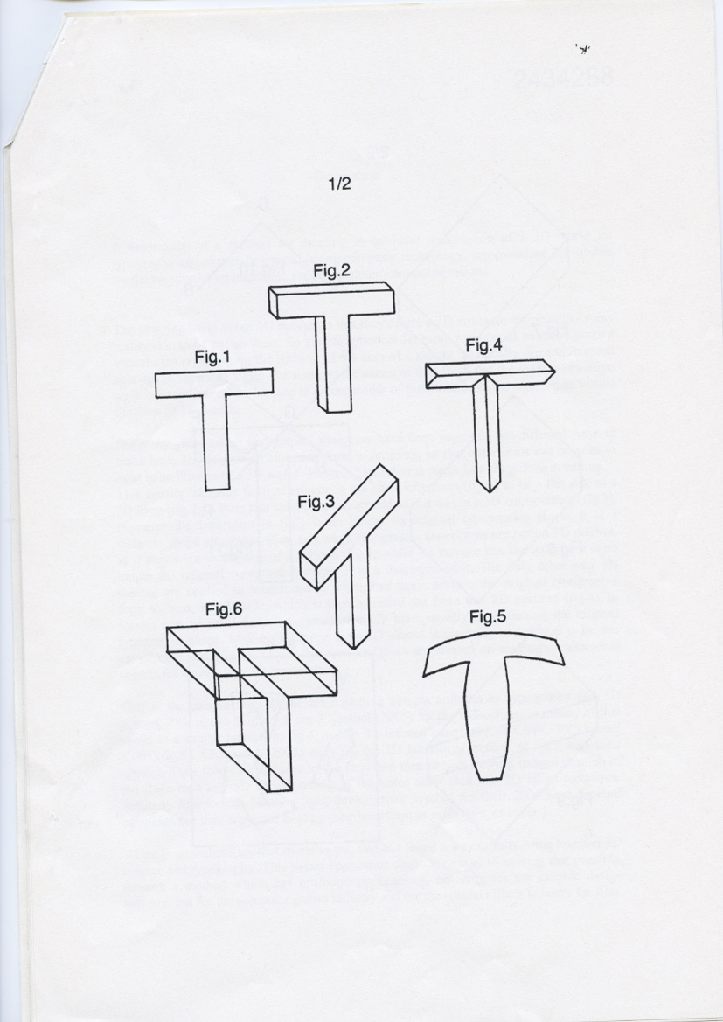

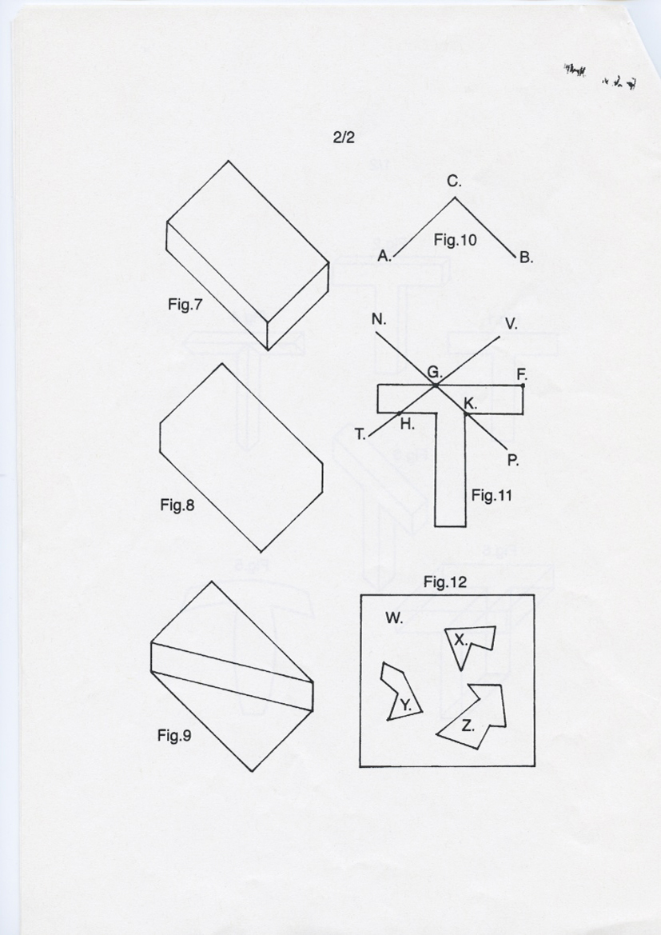

Description

A description of a method for computers to create an artificial imagination of a 3D world for typography and any other 2D shape or any conglomeration of 2D shapes, incorporating 3D meshes for the creation of architectonic visions, including animated visions.

The amazing thing about 3D meshes is that they create a 3D armature for potentially any reality skin to be put on them. As such, a basic spherical 3D mesh form could either be given a virtual skin representing the illusion of the skin of a peanut, or equally the architectural skin of the Sapporo Dome. The size and the nature of the object and the scale information on it is interchangeable, leading to a cornucopia of possibilities in the creation of virtual illusions of 3D worlds.

For many years artists and graphic designers have been searching for different ways to make texts 3D, to give architectural form to lettering, so that letterforms can be seen to exist in an illusion of a 3D world. These 3D letterforms are in fact ubiquitous in culture.
This usually takes the form of imagining the basic letterform (fig.1) to be a flat side of a 3D form (fig.2), a form that can be moved around as if it was in a 3D environment (fig.3). However the letterform in fig.3 is no longer its original typographic shape. It is a different shape altogether. Similarly when typographic letterforms are put on 3D meshes, as if they were on the side of a balloon (fig.5), again we can see that the letterform is no longer the original typographic shape. It is a distortion of it. The only other way 3D meshes are applied to letterforms is when they again assume the original typographic form to be a flat 2D side, which is then extruded out from that 2D position (fig.4), to form a sort of relief from a perpendicular 2D base, usually transgressing the original typographic shape. Making 3D forms from 2D shapes is generally understood to be this act of extrusion (fig.6). This is because designers are fixated on making architectonic objects for a navigable 3D environment.

That is the current state of the art regarding current attitudes to typography and 3D visions. This is exemplified in the 3 Symbol (2005) for the videophone company of that name, in a similar manner to fig.4, or like the inflated letterforms of CBBC TV channel (2005)(fig.5). Channel 4 (2005) goes for the 3D letterform method of fig.3 with their symbol. They then cut 2D holes in the form and then project moving images through it, but there isn’t any 3D understanding of the holes other than this 3D effect technique. Similarly Macdonalds shone a light through their symbol for their 2004 Euro football campaign but they were still treating their letterform as a 2D hole, as in fig.1.

This patent application describes a way of making possible the bringing together of 3D meshes and typography and other 2D shapes, through a method which has profound implications, not only for the graphic design industry, but for the computer games

2.

industry and for the special effects industry for film, in fact it could signify a revolution in the CGI industry as a whole.

A typographic letterform is ordinarily comprehended as a 2D shape perpendicular to the image plane. One sees the capital letter T, for example as consisting of a vertical 2D line with a horizontal line on the top. Our identification with the form is such that we can’t really conceive of it ordinarily any other way. It is this identification with the form as a 2D shape that has stopped the development of its potentiality as a 3D architectonic representation.

If one looks at Fig.7, one sees a slab-like architectonic form in isometric projection. However when one sees the same form as a silhouette (fig.8), one looks at it as essentially a 2D shape. That basic shape could, according to the geometry of anamorphic projection, isomorphically represent any number of 3D shapes, of which fig.9 is a simple example.

Through an application of this insight one can realise that a typographic letterform, which one would ordinarily conceive of as a 2D shape, could in actuality be the silhouette of a 3D shape, whose edge would not be perpendicular, but would consist of having foreground and background spatial co-ordinates.

In fig.10, if the line ACB were to be ascribed with anamorphic projective spatial values isomorphically, then point C could be in the mid distance of the 3D space and point A could be the background and point B could be the foreground and vice versa. Lines BA and AC could even represent curved lines. There are endless possible interpretations, which the computer is ideally suited to explore, as such beyond Man’s ordinary cognition.

In fig.11 if we ascribe anamorphic projective logic to such a 2D typographic letterform (or any other 2D shape or conglomeration of shapes), we can begin to understand the potential of that visual system to realise many different visions. For example if lines VT and NP were understood as being horizontal trajectories in a 3D perspectival space with for example, points P and T being towards the foreground of the 3D space and points N and V towards the rear of the space, then line GF could be ascribed anamorphic projective spatial values so that isomorphically that flat horizontal line could in fact represent a line at so many degrees angular to the plane GP where point F was spatially higher than point G. and that points H and K were nearer the foreground than point G.

Anamorphic typography does exist and is ubiquitous, in the form of anamorphic road signs on tarmac and it is also evident in all sports stadiums, where the letterforms are presented to the viewer as if in a perpendicular 2D state, but are in actual fact anamorphic

3.

projections manufactured to go on the side of the pitch, or painted onto the pitch directly. However they are so designed so that your identification with the letterform overrides the actual physical state of the letterform in reality, which when viewed from any other angle, is an absurdity. It is this identification that has masqueraded the potentiality of anamorphic text to be explored with 3D mesh technology. There is no 3D mesh anamorphic typography technology evident in culture. This patent application is simply the application of 3D meshes to typographic forms and any other 2D shape or conglomeration of shapes. With anamorphic projective geometric spatial co-ordinates ascribed, an isomorphic 3D mesh could potentially be created to realise an architectonic vision from typographic forms, as there would be a platform of spatial co-ordinates to attach the mesh, which was in the isomorphic mould of the 2D shape.

With a 2D shape one has a specific measurement to be contemplated as a variable. It forms a workable edge to the equation, so that it can be explored mathematically as a 3D architectonic matrix.

The purpose of this software idea is not to create a navigable 3D world from the letterforms, but to create a 3D visualisation of the typographic letterform or any other 2D shape or shapes, within their own template format. Like fig.3, if the forms were moved around, according to a 3D understanding of them, they would cease to be the original typographic shape and thus would not be original typographic forms with 3D meshes anymore. Thus it would not be 3D typography. The goal to make typography 3D has missed the target precisely because of this wish for a navigable 3D environment as opposed to simply a 3D visualisation. It is this specific misunderstanding that has limited the understanding of typography as a potential 3D form. The other main reason for a lack of development of 3D mesh typography is our identification with the letterform as a 2D shape perpendicular to the image plane, as previously described. To see it any other way is ordinarily beyond cognition, hence no development of the 3D concept.

This software idea has the potential to overcome this cognitive limitation in three ways, because computers have:

1. Freedom from identification. They can understand the typographic letterform simply as visual language to be manipulated according to instruction.

2. They can transcend the wavering mind. They can fix a vision and carry out visualisation instructions with absolute discipline and order, in ways that we cannot, such as mapping.

3. They have freedom from our cognitive limitations. According to our instruction they have the capacity to view any part of the image as representing either up or down,

4.

background or foreground. We can’t ordinarily do this. If we see two identical circles, even if we are told to imagine one as being small and near and the other as being big and far away, we can’t make such a distinction.

With these superhuman advanced facilities, the computer has in its power, the ability to bring us 3D visions that are ordinarily beyond our cognition to achieve. It could apply the “2D shape as being in actuality a representation of a 3D form” knowledge, not only to typographic letterforms but also to the shape existing around the letterforms, to create a total 3D world illusion. This total 3D world illusion could be an object illusion, an illusion of an object ordinarily beyond our wit to perceive. If we look at fig.12 we see an image made up of four shapes, W, X, Y and Z. Ordinarily one would comprehend it as three shapes, X, Y and Z, surrounded by a space W. If one imagines the three shapes to be 3D form silhouettes suspended in a 3D space, then one can make some interesting assumptions about them. If shape Y was ascribed spatial co-ordinates so that it represented something half a mile wide that was three miles distant and one mile higher from shape Z in the 3D illusion, then what that shape Y represented as a 3D form, would be entirely different than if, say, Y was only 10 metres wide and 50 metres below form Z. In this way, one can see the potentiality of the image to be a continual flux of 3D relativity. As a pictorial matrix WXYZ has a myriad spatial possibilities. If we now imagine shape W, not to be the space in between the forms, but like a 3D net joining them all up, then we can have an object made up of shapes W, X, Y and Z, as if, for example, shapes X, Y and Z were 3D appendages on the form W, like the nose and ears of a dog, or the wing mirrors on a vehicle or the bombs on an aeroplane.

Alternatively, each shape may have an entirely independent mesh within its own shape template that had no shared spatial co-ordinates with any adjacent shape so that a kind of 3D jigsaw of pieces was created. Another variant could be where the meshes were attached at certain points or for certain lengths to each other, whilst being unattached at other points or lengths along the edge of the shape. It depends on how many of the spatial co-ordinates are shared between shapes. Some shapes may conglomerate together to form clusters as a total conglomeration, as suggested as an object WXYZ in fig.12, or as a partial conglomeration, for example a hexagon may contain six triangles with independent spatial co-ordinates but that each separate triangle individually shared the external border of the hexagon, which was itself, independent in a melee of other shapes.

As with a silhouette, a 2D shape may be made of a single line, for example a squiggle, or a series of interconnecting lines that tallied in terms of sharing the same spatial co-ordinates at the meeting point on the shape, for example a hexagon, or they could be a series of independent lines that conglomerate to form the appearance of a shape, for example where the silhouette of an aeroplane had a propeller shape adjacent to the

5.

tailplane shape on the edge of the silhouette, in actuality the tailplane was not connected to the propeller and these lines had independent spatial co-ordinates to each other.

An individual 2D shape may be ascribed anamorphic projective spatial values so that it represents a planar surface in space, for example, as if looking down on an angled roof of a building at an angle of 30 Degrees, or it could represent a 3D volume with a volumetric form, like for example, a shoe-like form. The volumetric form’s topography could be either concave or convex or a mixture of convexity and concavity, but the volumetric form would not, in terms of the initial mesh attachment, transgress its original shape.

This 3D form illusion knowledge could be applied to any typographic script, be it, for example, Roman or Chinese or Arabic. It could be applied to any typographic logo made up of 2D shapes. It could be applied in fact to any 2D shape, however complex the edge, for example a brush stroke or a calligraphic mark. It could be applied to any pattern also to create 3D architectonic visions, so that a carpet design for example, could become an architectonic vision beyond ordinary cognition. It could be applied, in fact to any combination of shapes, however complex.

The matrix-enabling faculties of the geometric plasticity of visual language, allied with the spatial system of perspective, allow for such a plethora of interpretive possibilities, that any shape, or any combination of shapes, could possibly be animated from all the various “stills” that could be produced and put in a sequential order.

The artificial imagination (architectonic matrix) is, in this case, simply the scope of the information components to be all that they could be architectonically, according to all the anamorphic projective spatial values that could be ascribed to the original shape information.

The animation of the artificial imagination, is of a type where the original shape or shapes, remain constant and fixed in their place, whilst the 3D mesh of interpretation moves as it mutates according to the changing arbitrary spatial values ascribed to it, to create a conjectural mapping of the shape information, as spatial information. It is an enactment of an object being objectively considered according to a defined matrix of subjectivity.

In this way a 3D application can be created for typography because no change occurs to the basic shape outline of the original typographic letterform. The only thing that changes is the interpretation. What one has is an image that is simultaneously fixed and yet at the same time, moving, if this animation option is added. This has great potential for any kind of matrix computer game, where shapes, as forms, could change their architectonic

6.

meaning and spatial location at will. If the digital image was made up of pixels then this “shape as form” mesh technology could stretch down all the way to that base unit, to potentially add another level of detail to the image at any level.

7.

Claims.

Claim 1.

A 3D visualisation method for computers where a typographic letterform or other 2D shape has anamorphic projective spatial values ascribed to it so that a 3D mesh can be attached to the typographic letterform or other 2D shape at the points on the typographic letterform or other 2D shape where those anamorphic projective spatial values have thus been ascribed.

Claim 2.

A 3D visualisation method for computers as in claim 1, where the initial 3D mesh attachment does not transgress the original typographic letterform or other 2D shape.

Claim 3.

A 3D visualisation method for computers as in the above claims where the 3D mesh may differ in form according to differing spatial values ascribed to the original typographic letterform or other 2D shape.

Claim 4.

A 3D visualisation method for computers as in the above claims where various different mesh formation images may be put together in an image sequence to create an animation.

Claim 5.

A 3D visualisation method for computers as in the above claims where the edge of the original typographic letterform or other 2D shape is entirely spatially co-ordinated with the adjacent shape or shapes along the entire edge of the shape.

Claim 6.

A 3D visualisation method for computers as in the above claims where the edge of the original typographic letterform or other 2D shape shares spatial co-ordinates with the adjoining shape or shapes, only at specific points or lengths along the shape edge.

8.

Claim 7.

A 3D visualisation method for computers as in the above claims where the edge of the original typographic letterform or other 2D shape was entirely independent from any neighbouring shape or shapes.

Claim 8.

A 3D visualisation method for computers as in the above claims where an image contained an amalgam of shapes according to claims 6 and 7 combined together or claims 5, 6 and 7 combined together or claims 5 and 7 combined together.

Claim 9.

A 3D visualisation method for computers as in the above claims where the 3D mesh is planar, as if representing a planar surface in space, or that it is volumetrically convex or concave or a mixture of convexity and concavity.

Claim 10.

A 3D visualisation method for computers as in the above claims where the original typographic letterform or 2D shape was considered to be made up of a single line or a series of interconnecting lines that either shared spatial co-ordinates where they connected or where they did not share spatial co-ordinates at the point where they appeared to connect to form the original 2D shape.

Claim 11.

A 3D visualisation method for computers as in the above claims where if the image is made up of pixels of whatever shape or some other base unit of whatever shape, the above claims are valid all the way down to that base unit.

