Photographs Of Common Objects

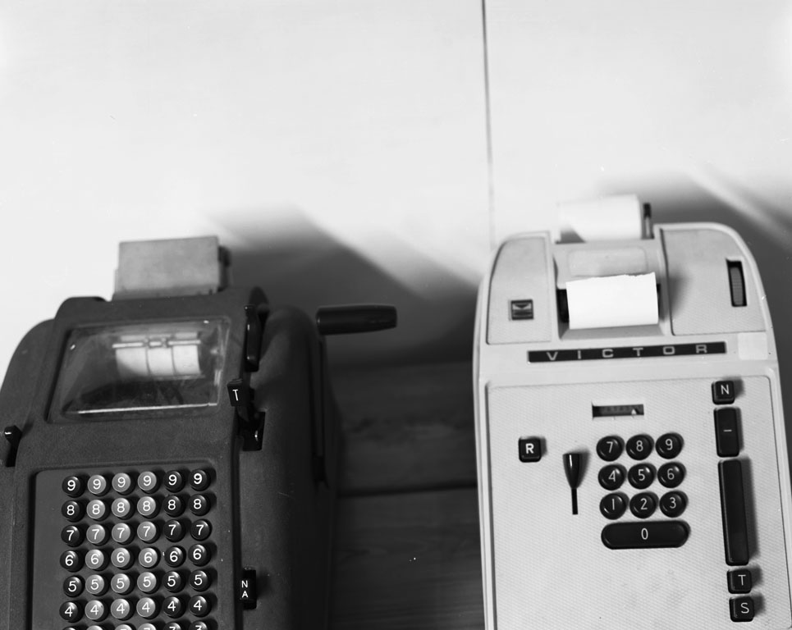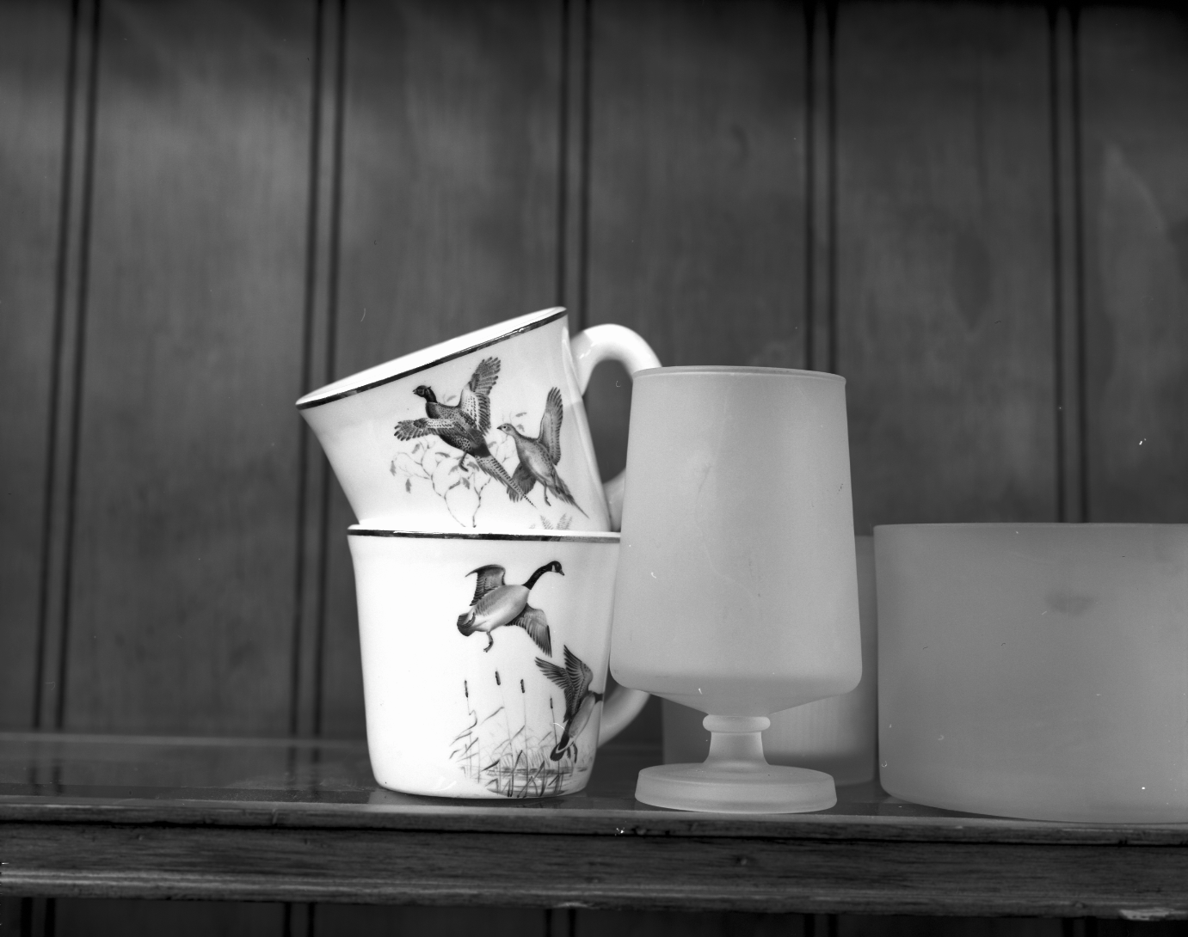

For the series of black and white still life’s, Photographs of Common Objects, I used a 4” x 5” view camera to capture in fine detail, the form and surface of relics from daily life. Among them - adding machines, ceramic, glass, and plastic cups, kitchen utensils, counter, desk, and table tops. The objects are found (in position), nudged, or firmly placed in front of the camera, at a short distance to reveal the peculiarly detailed nature of form and surface. The small worlds on the surface of, in between, and around the objects are typically given an as important formal role in the photograph as the objects. These small worlds consist of light, space, and texture and are used in conjunction with parts of or the whole object(s), to create the end composition. In addition to the formal consideration I give the photographs, the objects and scenarios are instinctually arranged to convey themes of commerce, domesticity, and leisure. There is no pretense of a fixed connection between the photographs but instead the photographs are symbols of a routine yet enigmatic existence.

I accept uncertainty towards the selection and composition of subjects to photograph—this is an integral part of my photographic process. The uncertainty serves as a constant reminder there are an infinite number of pictorial strategies, even within a confined space. The consideration of various pictorial strategies within a confined space slows my process down considerably and is designed to prevent me from looking away from the subject or looking for another subject too quickly.

The second series of images (7-12) are from a project being made inside a used furniture store located in Lima, Ohio. My experience in Lima has served as an enchanting introduction to a “typical” Midwestern town marked by a storied blue-collar work ethic. This work ethic closely followed the rise of industry in this area once a part of the iron belt and still perseveres now that it is unwittingly a part of the rust belt. I am currently working within both the landscape (Images 1-6) and still life (Images 7-12) genre, and I am motivated, not burdened, by established pictorial conventions. The photographs are not planned or composed in advance of the travel to each site, and are the result of patient observation and contemplation of the subject over a sustained period of time. My prevailing thematic concerns with both projects are studying the changes, large and small, occurring within an ordinary environment that results from a local Midwestern economy.

