Project title: ‘Against the fall’
Project outline (Version Ia):
‘Against the fall’ consists of a fully functioning white parachute and about 300 (or more) A4 rejection letters from art students and artists worldwide, which are printed onto the parachute.
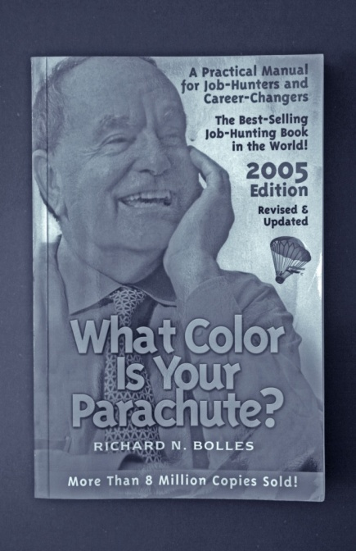
The parachute as such is a means of transport, an apparatus allowing the attached person or object to descend slowly from a height or to retard motion in another way (OED). The parachute decelerates the otherwise free fall and is just like the ‘safety net’ a device, which is supposed to prevent you from fatal collision with the ground. With regards to this, the parachute has a highly emblematic meaning, representing the plan of action, the strategy or the project that helps you overcome obsticals and difficulties. The parachute also touches upon concepts such as dislocating or relocating, arrival and entering, all of which play an important role within this project.
Initially, the work was solely about my own identity and situation as an emergent artist. Struggling to make my first steps in the art world and sending out applications for competitions, prizes, exhibitions and funding, I received heaps of rejection letters. Then I stumbled over the book What colour is your parachute? A Practical Manual for Job-Hunters and Career Changers and decided to turn the rejections into my very own fully functioning parachute with which I would jump into the next Venice Bienniale (hoping of course they would reject me first!).
Version IIa (existent work)
An installation comprising 18 miniature Da-Vinci style parachutes (rejection letters, wood) & a series of six black & white documentative photographs. Two of the parachutes were given back to the institutions (Kettle’s Yard and Wysing Arts Centre)that had rejected me.
