

APPLICATION FORM

Name: Paul Beuchat / Martin Rasmussen

Postal Address:

46 Paddock Road, London NW2 7dl
England

Email: p_beuchat@yahoo.co.uk /

Contact Number:

Paul Beuchat 07931530993

Martin Rasmussen: 07909900498

Checklist for inclusion:
- Completed application form
- Exhibition proposal not to exceed more than two pages (single-sided)
- CV not to exceed two pages (single-sided)
- Supporting visual material (in a word document) not to exceed 15 images

Applications to be sent to:

curatorialopen@southbankcentre.co.uk

Please also tell us how you heard about the Hayward Touring: Curatorial Open
Email

Other (please specify)

The Critical Network

Hayward Touring
Southbank Centre
Belvedere Road
London SE1 9XX
curatorialopen@southbankcentre.co.uk

MUSCLE BOUND: THE PENCIL DRAWINGS OF JACK KIRBY AND TOM OF FINLAND

A drawing project for HAYWARD TOURING: CURATORIAL OPEN

Team: Paul Beuchat, Martin Rasmussen and Elisa Ferrero

- Background:

Caricature is a useful tool to engage reality and “see” it from a different perspective because it questions the very foundations of the reality from where it emerges.

In his essay Laughter an essay on the meaning of the comic Henri Bergson tells us that humour is a form of code shared by the members of a group. He also tells us that humour is a dispassionate, formal mechanism that rules out emotion, revealing the absurd and the incongruous in the everyday and through it, the inner workings of humour. Caricature brings this underlying order and codification to the fore, disrupting the cinematic quality and superficial continuum of reality as we perceive it, opening up spaces for alternative thought.

In the face of it, a comparison between the drawings of Jack Kirby and Tom of Finland might seem like a caricature or, at least a very blunt instrument. However, the comparison proposed here takes on the obvious aspect of sexuality as a given, while at the same time it offers additional means for a dispassionate examination of form in the work of two artists who have many iconographic similarities.

Seen together in the context of the exhibition proposed, the extreme pairing of Jack Kirby and Tom of Finland defines the outer parameters of a model of observation. The purpose of the model is to examine the drawn line as a vessel, as fluid and mobile form capable of defining boundaries and creating spaces based almost exclusively on qualities of line, form and representations of space irrespectively of subject matter. Selected aspects of iconography (fashion, uniform) provide the objective markings required to examine the work of these two artists.

Conceivably, the focus of this basic proposal could be expanded to include other issues and points of view, for example:

- Oh Mac, you’re a real man after all!: Changing Perceptions of Male Musculature in Drawing 1960-2008
- Beyond Average: Vitrubius , the Farnese Hercules and the Hulk
- The Sexuality of (Dynamic) Perspective in the drawings of Jack Kirby and Tom of Finland
- Hero: Uniform and Identity in the Drawings of Jack Kirby and Tom of Finland.

We would try to touch upon some of these issues in an essay about the exhibition, but we feel it is more effective to focus on visible aspects or elements of code that these artists’ have in common such as: representations of musculature and uniform and identity in order to extrapolate them and in doing so attempt to expose and reflect generally upon the nature and role of the drawn line both as a container and also as a reflecting surface. The work of these artists is only a means to do that.

We have focused on these two “markers” in particular because they are key objective elements in the work of both artists and because their work reflects, as we mention above, two subjective polarities in a process of change in social perception of male musculature over the years and this change is more evidently reflected in the differences there is in the quality of the drawn line in their work. Also, uniform is a key aspect in the construction and identification of a drawn character and its history.

When you look at Superman’s uniform you know (because you have been told since the 1930s) that Superman comes from another planet, that he has a secret identity, that he has superpowers, that his uniform is immune to bullets, fire, water...his enemies, his adventures, etc. All this information is contained and reflected by Superman’s uniform in a way that his body (of steel) cannot, because it is anonymous, standard, there are no outer signs that may indicate its indestructible nature. It is the suit that stores and bears the identity and also the memory of the story of Superman.

Tom of Finland’s sailors are similarly iconic and at the same time lacking in individuality and identity, with roots in the old Navy Cut brand of cigarettes and its logo of a sailor with a cap that says “hero”, Gene Kelly’s camp sailor-in-the-big-city films of the 1950s, Frankie Avalon and Anette Funicello’s beach party films of the early 60s and finally Marlon Brando in a leather jacket and sailor’s cap as a 1950’s motorbike gang leader. Between the time Jack Kirby Began to draw comic books and today, with the work of Tom of Finland in particular, these icons and accessories of masculinity have been appropriated and divested of their original meaning to the point of deleting any links and traces that might connect them to their original meaning in the minds of today’s viewers.

The project MUSCLE BOUND: DRAWINGS BY JACK KIRBY AND TOM OF FINLAND remits the viewer to this process, but seen from the formal point of view of how a simple pencil line depicting the same anatomy can contain, express and reflect entire social processes.

- Proposal:

For HAYWARD TOURING: CURATORIAL OPEN we propose a small exhibition of the drawings of Jack Kirby and Tom of Finland focusing on their pencil drawings of male figures.

Comic book drawing involves the work of two separate artists “the pencil” and the “inker,” both of which have clearly defined creative roles in the process. Because this is not the case in the work of Tom of Finland, we feel it would be more helpful to limit our observation to the pencil drawings of both artists.

The choice of images should balance the iconic and the generally descriptive and the mechanisms and systems of comic book drawing will be mentioned. However, Jack Kirby’s comic book characters are better known and therefore have a greater “market presence” than the characters of Tom of Finland. This is due mainly to the epic narrative of their origins and adventures and we do not want any public awareness of such references to generate unfair perceptions of imbalance or judgement that might distract the viewer from our primary interest: the issue of line and content in drawing.

For this reason we would make every effort to obtain drawings by Kirby that depict some of his lesser known characters.

The focus of this project is a formal observation of the drawn line as a vessel and mirror through an extrapolation of examples of the work of these two artists.

TEAM

Paul Beuchat

Visual artist and translator

BA, Painting, Pontifical Catholic University, Santiago, Chile, 1985
M.Phil, Drawing, Royal College of Art, London, 2003
MSc, Technical Medical and Scientific Translation
with Translation Technology, Imperial College, London, 2007

Currently Managing Director, Line & Sound Publishing Company Limited, UK Reg. 6658024

Awards:

2008 International Books for Youth (IBBY) Basel, Switzerland, Honor List 2008, for the translation into English of the “Papelucho” series of children’s stories.
2003-4 Year of Drawing Fellowship, The Prince’s Foundation and Drawing School, Shoreditch, London, UK
2003 Fund for the Development of the Arts, FONDART, Ministry of Education, Chile
2002 Soroptimist Society, study scholarship, London, UK.
2001 Tom Bendham Drawing Prize, Royal College of Art, London, U.K.
- Fund for the Development of the Arts, FONDART, Ministry of Education, Chile
- University of Valparaíso Prize (First Prize) Young Art, Valparaiso, Chile.

Written essays:

2008 “London Biennale, ¿un modelo de Bienal para el future?(London Biennale: A model of Biennale for the Future?” For publication by “Cuadernos de Arte UC”, published by the Pontifical Catholic University of Chile, Santiago, Chile, November 2008.
2008 Lanudo: a “strange” drawing by Dominique Serrano, essay on the work of Dominique Serrano.
2007 “A Method to Identify and Define the Boundaries of Provisional Terminological Spaces usable for the Hypothetical Discussion of Emerging and Unnamed Phenomena and Based on the Visual Observation of Groups of Discipline-Specific and Associated Terminology in Flows of Natural Language as a proposed structure for a Dictionary of Advanced Drawing, MSc Dissertation, Imperial College.
2006 The ghost of the father: photographs by Nurcan Ozagi
2005 El Perro de Goya: emerging form and content in the work of Ignacio Valdes,
2004 Life Class: 100 Drawings, The Prince's Drawing School.
2003 The Little Birdhouse in The Sky, essay for Graduate Exhibition Catalogue, RCA, London
2003 Boat Memory: the mythmaking role of distance and mobility in the work of the contemporary artist, MPhil Dissertation, Royal College of Art, 2003
2001 A Distant Portrait, Notes on the Paintings of Ximena Cousino, exhibition catalogue, La Sala, Santiago, Chile.
2000 Off White, Josefina Guilisasty Works, 1987-199
2000 Time Over Matter, Isabel Del Rio, Works, 1987-1999
2000 Double Helix: Drawings by Dominique Serrano and Alejandra de Solminhiac, exhibition catalogue.
1999 Blue Collar Realism, the paintings of Augusto Jara, catalogue essay.
1999 The Magic Mountain: Notes on the Painting of Isabel Saa, exhibition catalogue essay, Galeria Arte Actual.

List of Exhibitions since 1989 (summary)

One-man Shows

- Eyes Faces, Bodies” Computer Graphics and Painting, Contemporary Art Gallery, Buenos Aires, Argentina.
Half a Tunnel, Computer Graphics, Lo Contador Campus, Catholic University of Chile, Santiago and School of Engineering, University of Chile.
- Interface, Computer Graphics, Viña del Mar Gallery, Viña del Mar, Chile.
- The Passageway of the Flies, Drawings and Watercolors, Escuela Moderna Gallery, Santiago, Chile.
- Keeping an Eye on the Meat, Drawings, Benjamin Vicuna MacKenna Museum, Santiago, Chile.
- Inventory, Manuel Robles Gutiérrez Gallery, Renca, Santiago, Chile.
- Drawings, Claudia Missana / Paul Beuchat, Galería del Cerro, Santiago, Chile.
“Drawings”, DUOC foundation, Vina del Mar, Chile
- Museum Piece, Center for Continuing Education, Pontifical Catholic University of Chile, Santiago, Chile.
2002 Drawings, Hockney Gallery, Royal College of Art, London, UK.

Group Shows

- The Tree, National Museum of Fine Art, Santiago, Chile.
- Four Students from the Catholic University, Goethe Institut, Santiago, Chile.
VI Valparaíso International Art Biennale, Valparaíso, Chile.
1986 Paintings, Bucci Gallery, Santiago, Chile.
Sobrepapel, Works on Paper, Eugenio Castro, Paul Beuchat, Espaciocal Gallery, Santiago, Chile.
- First Latin American Encounter of Works on Paper, Latin American Association of Plastic Artists, ALAP, Buenos Aires, Argentina.
- Second Latin American Encounter of Works on Paper, Contemporary Art Gallery, ALAP, Buenos Aires, Argentina.
- Chile-France Biennale, French Cultural Institute, Santiago, Chile.
Latin American Artists in Rome, Argentina House, Rome, Italy.
Third Latin American Encounter of Works on Paper, ALAP, Buenos Aires, Argentina.
- Overture 8, Nexo Gallery, Santiago, Chile..
National Juried Exhibition, San Diego Art Institute, San Diego, California, United States.
Open Museum, Chilean Contemporary Art, National Museum of Fine Arts, Santiago, Chile.
XII Young Artists Competition, El Farol Gallery, University of Valparaíso, Valparaíso, Chile.
- Group Exhibition, Chiloé Museum of Modern Art,
Art on Paper 1991, Maryland Federation of Art, Annapolis, Maryland, USA.
SOHO on the Run, Montserrat Gallery, New York, United States
Prix Ars Electrónica, Linz, Austria.
- Group Exhibition, Chiloé Museum of Modern Art, Castro, Chiloé, Chile.
- Group Exhibition, Abney Galleries, New York, United States.
Collection of the Valdivia Museum of Contemporary Art, National Museum of Fine Arts, Santiago, Chile.
Exhibition of Past Winners of the Young Artists Competition, Valparaíso University, Valparaíso, Chile.
- Anomalies, Paul Beuchat, Pablo Rivera, Victor Hugo Bravo, Felix Lazo, Posada del Corregidor Gallery, Santiago, Chile.
1998 Social Security, Installation, Instituto de Normalización Previsional, INP, Santiago, Chile.
- Laboratorio 9: PostHUMAN,, Balmaceda 1215 Gallery, Santiago, Chile.
Drawings and Objects, Paul Beuchat, Cristián Silva, BECH Gallery, Santiago, Chile.
International Biennial Print and Drawing Exhibition: R.O.C.., Taipei, Republic of China.
Bodega 4, Group Exhibition, Vitacura, Santiago, Chile.
- Latin American Painters, Instituto Cervantes, London, UK
Someday all this Will be Yours, School of Sculpture, Royal College of Art, London, UK.
2002 Work in Progress, Drawings by Elaine Kowalski, Gail Henderson and Paul Beuchat, Drawing Studio, Royal College of Art, London, UK.
2003 The Show I, Royal College of Art, London, UK.
  - GASCO Gallery, Santiago, Chile
Summer Exhibition, Case-1 Gallery, London, UK
Drawing Year2003-2004 Exhibition, The Prince's Foundation, London, UK
Ice cream, you Scream, Herbal Hill Gardens, London, UK. Curator: Martin Rasmussen
2005 Abrupt, Nanospace, London. Curator: Martin Rasmussen
2006 Ciruito Local, Galeria Caligrafica, Molina, Chile
Blyth Gallery, Imperial College, London, UK
2007 Rights of Way, Southwark Park, London. Curator: Martin Rasmussen

Translation Projects

- Psychological evaluation report for Chiletabacos (Client: Ailsa F. Shaw for British American Tobacco) (2008)
- “Operations Plan and Actions in Case of a Fire Emergency and the Evacuation of Naval Facilities at Asmar Talcahuano” (Naval Shipyard, Client: Ailsa F. Shaw for Claro & Marsh, Santiago, Chile) (2008).
- Series of 12 children’s stories (Papelucho), with Ailsa F. Shaw and Linda Craddock, IBBY Award (2007)
- Mellado, Justo Pastor, La Novela de Inscripción de Osvaldo Salerno CAV/ Museo del Barro, Asunción, Paraguay, 2006.
- Thayer, Willy, Inside the Cone of Silence, CAV/Museo del Barro, Asunción, Paraguay., 2006
- “Comparing Different Types of Expenditure on Teaching and Learning Materials”, Mike Horsley, University of Sidney, paper for International Seminar on School Texts SITE 2006, 05-09 April, Santiago, Chile.
- “Pedagogical Texts and Digital Portfolios” Bente Aamotsbacken and Susanne V. Knudsen paper for International Seminar on School Texts SITE 2006, 05-09 April, Santiago, Chile.
- “Environmental Services Agreement” (client: Asltom, Chile), 2006.
- Barría Jara, Mauricio, To Contemplate: variations on the subject of the archive, Gabriela Mistral Gallery, Chilean Ministry of Education, Chile, 2005
- Essay for the Exhibition 100 Days at the End of the World, Museum of Visual Arts, Santiago, Chile, 2005
- “Growing Gap in Self-Generated Income Between Genders: Elements of the PFA System and Employment Practices that Explain this Phenomenon”, July 2005 (Client: Linda Craddock for Superintendency of Pension Fund Administrators, Chile)
- “Addendum Transmission Concentration and Compression Systems” Tender Documentation, Telefónica Movil, Chile.
- “RFQ Switching 4 and Backbone- Signature Control Table” Tender Documentation, Telefónica Movil, Chile.
- “Outline of the Main Changes Introduced by Chile’s New Industrial Property Law” , 2005 (Client: Beuchat Barros and Pfenniger Abogados)
- “Ukraine Private Pensions System – Project to Implement a reform in the Ukranian Pension System (PO83726) Proposal – Criteria and Procedures for the Appraisal of Assets Belonging to Non-State Pension Funds” for PrimAmerica Consultores, June 24, 2005.
- “Special Administrative Bidding Conditions, Supply, Erection and Commissioning, Electrostatic Precipitators for Teniente Converters No1 and No2” CODELCO Chile, El Teniente Division, Project Management Office, Project Studies Superintendency (2005)
- Bylaws Empresas Melon S.A., Chile (Lafarge Group, France)
- Tender documentation “Puerto Montt Grinding Station, Project Reference Number BAM 509, Nature of tender: Turnkey
- “Standard Operating Procedure: Rockfall Evaluation and Safety Clearance Procedure, Date issued 2003) (Client: Ailsa F. Shaw for Minera Los Pelambres, Chile)

Martin Rasmussen

Curatorial Experience

“Park Attractions”, (Projected)
Southwark Park, London March-May 2009
Outdoor exhibition with five artists developing an exhibition that wants to invent future activities in The Park.
In collaboration with Cafe Gallery Projects.

/seconds 8, March 2008
Publication website exhibition, http://www.slashseconds.org/issues/002/004/articles/phenomenalexchange/articles/rasmussen/index.php
Exhibition curated within larger exhibition. Artists allowing themselves to choose a piece of work that might not be considered to be work.
Tsai-Wei Chen, Guy Harries and Richard Thomas. See images below.

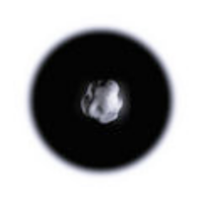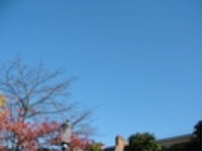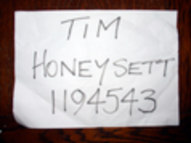

“Island”, March 2008
Way East, London, http://wayeast.russellmartin.org.uk/
The idea of an island, such as where the gallery is situated, Hackney Wick, The Wicker Man and other cultural references.
Alexander Hidalgo, Niki Kyriakidou and Hannah Terry explore these aspects with the help from the London Olympics and J.D. Ballard’s Concrete Island.

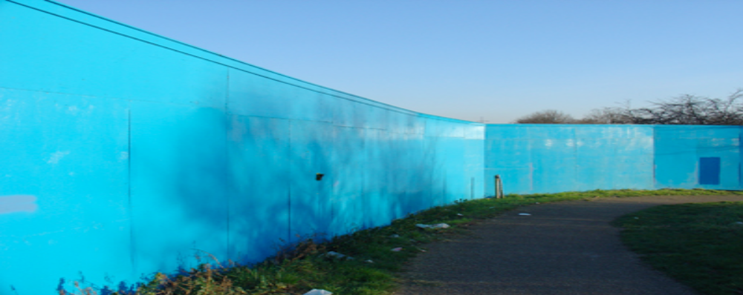

“Rights of Way”,
Southwark Park, London May-July 2007
Arts Council funded outdoor exhibition with nine artists investigating what is natural and what is not. Attention is being paid to
The Park and what influence it has on the urban and more importantly how The Park is perceived within this context.
Artists A.S., Paul Beuchat, Carl y Simon, Marcia Farquhar, Alexander García Düttmann, Alexander Hidalgo, Niki Kyriakidou, Monika Oechsler, Simon Patterson.

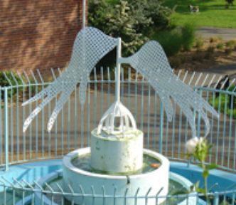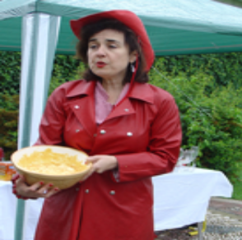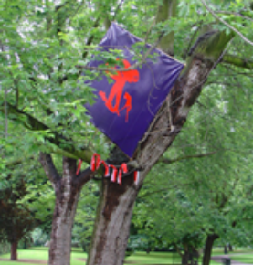

“Repellent”,
Nanospace, London Dec 2006
Drawing exhibition paying attention to the erotic space between totalitarianism and capitalism.
Curator and artist working closely together with text and drawings. Artist Alexander Hidalgo. See images below.

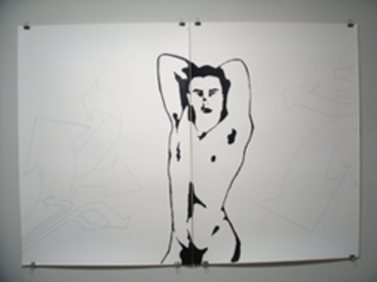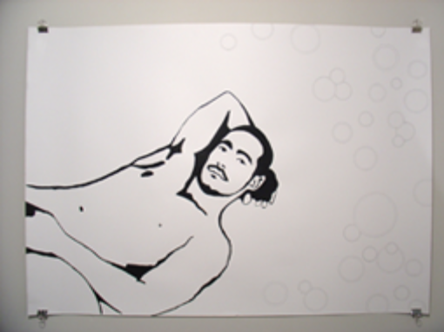

“Abrupt”,
Nanospace, London Jan/Feb 2005
In Abrupt we have undergone research. Through drawing we experiment with ‘rule setting’ and how confinement for the artist can
develop art making. How/if artists use memory in their work, and is this enabling. How does that work provoke/provide for the viewer?
What impact does the medium have? To simplify: is the “going-outside” of the artist provoking a “going-outside” for the viewer? Artists Paul Beuchat, Alexander Hidalgo, Elizabeth Knowles, Richard Thomas. See images below.

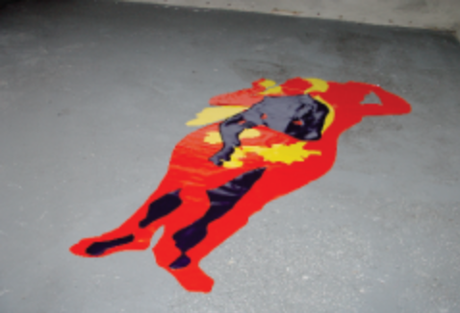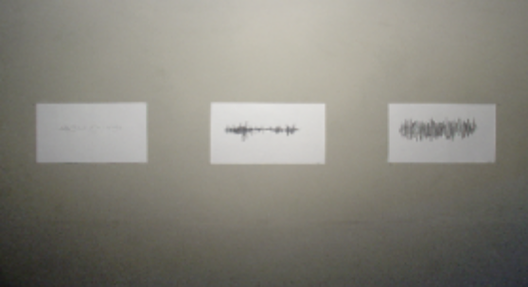

“Ice Cream You Scream”,
Herbal Hill Gardens, London Oct/Nov 2004
Curated with Sandra Pusterhofer
Exploring that which never stays the same. The public/private space utilised was purpose built as offices, presently functioning as luxury-flats for professionals, latest
usage: exhibition space. Work in exhibition reflects both space as well commenting on arts potential to disrupt subjectivities that consequently don’t stay the same either.
Artists Paul Beuchat, Chris Cook, Alexander Hidalgo, Elizabeth Knowles, Niki Kyriakidou, Verena Resch, Rachel Ryvar, Simon Streather, Richard Thomas, Mary Ruth
Walsh. See images below (next page).

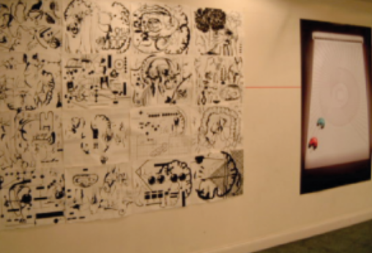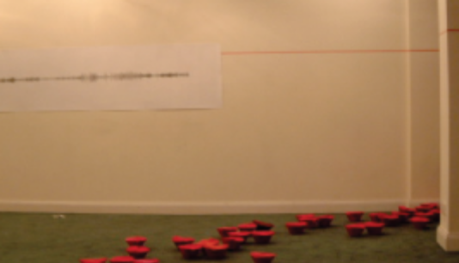

“M’aidez”,
temporarycontemporary, London May 2004
Assisted Alexander Hidalgo.
Exhibition within bigger event, FLEA MARKET.
Highlighting the disappearance of the labourer. 10 artists; Tasha Amini, Jeremy Deller, Caitlin Elster, Jez Jacobs, Niki Kyriakidou, Johannes Maier, Monika Oechsler, Giles
Perry, Simon Streather, Annie Whiles, Steven Williams, Yukinory Yamada. See images below.

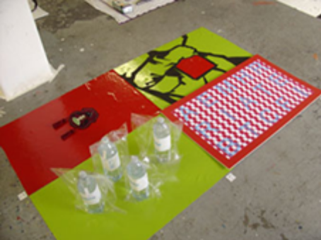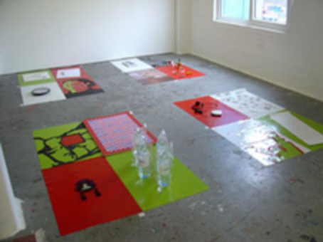

Funding Received
Arts Council England, funding for the arts for Rights of Way, Southwark Park 2007

Qualifications/Training

MA Contemporary Art Theory 01/10/04 - 01/10/05
Goldsmiths College, London

BA, Art History 01/10/01 - 01/05/04
Goldsmiths College

Professional Experience

Damien Hirst, Peckham, London 14/01/08 - present
Administration Assistant for Damien Hirst studio
SUPPORTING MATERIAL

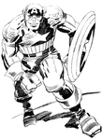 | Jack Kirby, Captain America
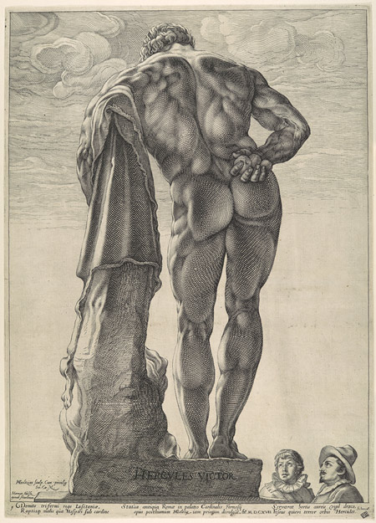 | Henrick Goltzius, The Farnese Hercules
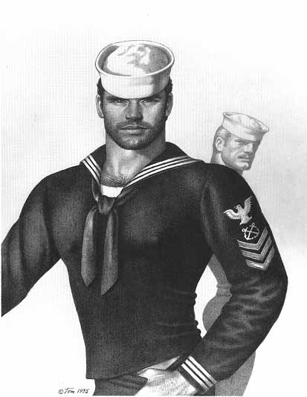 | Tom of Finland, sailor
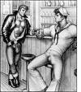 | Sailor, Tom of Finland.

