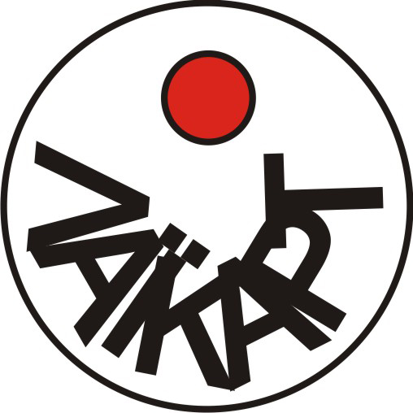LAIKART
artist group for unrealized utopian projects

Inception
LAIKART was an artist group founded in Athens, Greece, by Eirene Efstathiou (artist), Maria Michou (architect) and Iris Plaitakis (artist / archaeologist). In 2006, when LAIKART took shape, we were already friends, newly repatriated, and felt marginalized from the local art scene of Athens. In need for a sense of (artistic) community, we decided to formalize our shared interest in the city and flaneury by forming the art group LAIKART [LAIKO + ART in Greek translates to POPULAR + ART].
1st (unrealized) project
The first project we set out to undertake was a Diego Rivera-esque mural featuring images from the contemporary pop culture of Greece. Images such as ‘Anna Vissi at Eurovision’ [a popular kitsch Greek singer who represented the country at the annual Eurovision song contest] would be wheat-pasted on the premises of the 1st Athens Art Biennial—commenting also on the exhibition’s symbolic title ‘Destroy Athens’. The idea was never materialized.
2nd (unrealized) project
The second project, which actually became the focus for the group throughout its duration, was ‘Site Seen’. This involved the creation of an archive of images from the interior elevations of demolished homes, which appear on the neighboring party walls once the structures are taken down. Partly nostalgic of a smaller-scaled urban structure--symbolizing our own childhood homes--partly wondering about the future of the city as it would materialize in the construction of new multi-storey apartment blocks, we planned to produce and exhibit work in close collaboration with each other. The project went as far as photographing such elevations-sites, individually or as a group, but never actually took shape under LAIKART. However, Eirene and Maria did carry on with the project later in 2009 and 2010, and exhibited their works in public art venues of Athens. After it became apparent that ‘Site Seen’ would never be carried out via LAIKART, we discussed of, at least, offering our digital archive of images to a public archive. This never happened either.
[what we did do]
- We went on a trip to the Venice Biennale in 2007.
- Attended, as a group, a three month seminar by Professor of the Athens Polytechnic School, P. Tournikiotis on the architectural history of Athens since 1830.
- Eirene and Iris practiced a derive along the electric train lines from Pireaus (the main port of Athens) to Kifissia (the aristocratic suburb of the city since 1600s).
- All three members practiced two derives in the coastal industrial suburb of Elefsina.
- We planned doing a derive to a smaller coastal suburb of Athens, Lavrio, which also exhibits post-industrial ruins and a peripheral sense of place—much like, yet different from, Elefsina. Eirene ended up doing the derive on her own.
- We did have group meetings and retreats where we discussed our unrealized projects. We often kept meeting minutes during our meetings.

the heroic demise
Soon before the dissolution of the group, we discussed of, at least, writing up a CV of our unrealized projects—something which, again, we never did.
In due course, we became more active participants in the local art scene (Eirene won the Deste Prize in 2009, Maria wrote the catalogue text for Eirene’s work), and this is when LAIKART made its most public appearance. The group was referenced on a wall text for Eirene’s paintings, inspired by the ‘Site Seen’ concept, as a work ‘in collaboration with LAIKART’, whilst Maria referenced the group’s name in her critical catalogue text. We all declared our membership in LAIKART in the context of ‘facebook’ relationships.
Zero to Hero
Today, we continue to collaborate but no longer consider ourselves members of a formal group. Having joined the mainstream of a peripheral art scene, we wish to maintain the spirit of LAIKART in spontaneous collaboration. We believe that any scene, no matter how ‘backwater’ it might be, still has an institutional structure. LAIKART’s ‘unrealized’ character helped us remain outside of any such structure, and opened up a conceptual plateau for utopian projects, discussions, a sense of community. Being an entirely self-referential artist group, it realized the possibility of belonging in a collaborative space unbound to the conventions of any formal artistic practice or institution, yet containing of our spontaneous and unplanned rushes of thinking and creating.

For (ex-) LAIKART
Eirene Efstathiou, Maria Michou, Iris Plaitakis

P.S. LAIKART (even) had a logo (see above)

