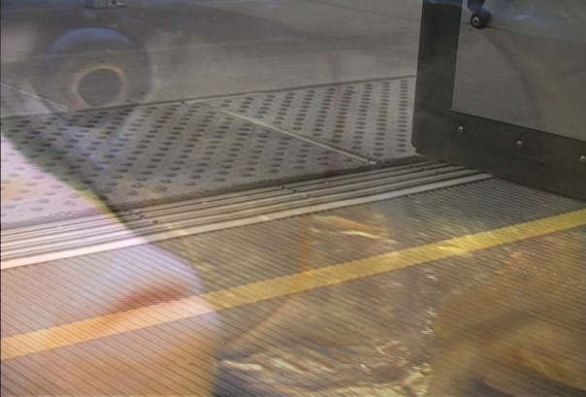
Where Did My Husband Go...?

This two projection and six single channel video installation, based on a personally written poem entitled the same, presents images of contemporary times but reflects back to the Middle Passage, approximately 1440- 1640’s and the Africans who lost their lives while in captive transit. The installation of this piece requires two walls in the shape of a bow, the forward or stem of a ship, with three monitors (totaling six signal channel monitors with two DVD outputs) at the waters line on each side of the bow. The two projected images on the walls will be in reverse as to appear to be in bowed reflection. At the bottom three monitors to one side of a ship’s forward shaped wall will be in reverse of the three monitors on the other side of the installation. This reverse projection and monitors images help create a sense of motion moving forward as if the ship was coming towards the viewer.

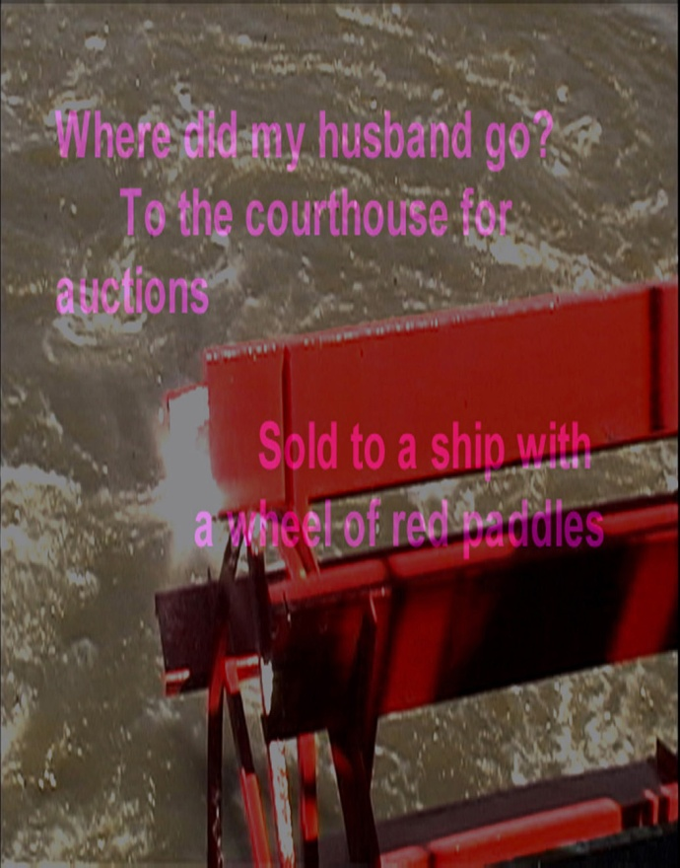The piece is reflective of the potential of lives. Lives both lost and the loss of relationships that could have been. Based in St. Louis, Missouri, USA, an active community in slavery, the works presents images of the original St. Louis Courthouse that sold bankrupt family estate’s “property” on the front steps of the building. This “property” included slaves belonging to the newly insolvent families. The building located at the edge of the river named “the mighty Mississippi,” which Mark Twain made famous in his writings of the river and slavery in The Adventures of Tom Sawyer, 1876, and the Adventures of Huckleberry Finn, 1885. In addition, images of men and woman’s shoed feet on the Metro Link commuter rail transporting the unidentified workforce from home to their employer’s facilities. Images with in the video consist of; the paradise blue or the Atlantic Ocean where the "Kingdom of Bones" rest. The kingdom of bones represented by images of captured fish, sharks and jelly fish video recorded from Aquariums in the southern region of the United States. This piece pushes the relationship between African men and woman, captive during the slave trade, and a contemporary white woman and the potential for families lost then and now.

Poem:
Where did my husband go. . .
To the courthouse for auctions
Sold to a ship with a wheel of paddles
Turn’n round in the water
Wondering nearby
I ain’t the writ colour

Where did my husband go
Northbound, Moonward
La lune does not rest
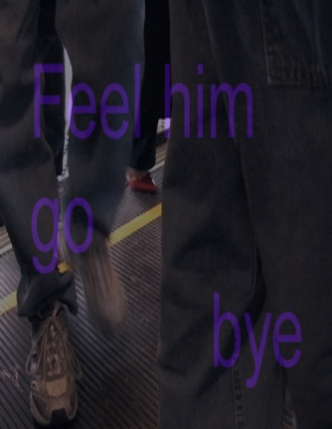
I note the write colour
The music I ear is his
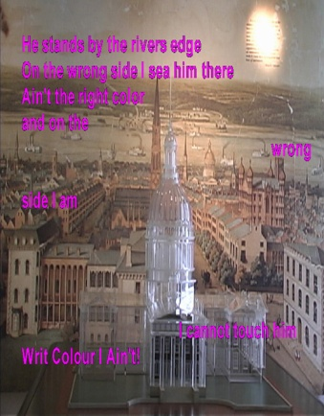
I’m at that whipping place
A space Bloods run from
I feel him go bye
I’m not the right couleour

Where is
my, the
husband
that I could not have
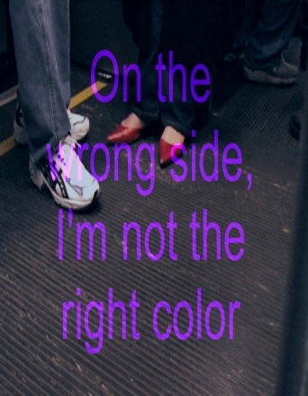
He stands by the rivers edge
On the wrong side
I sea him,
rememory once there
Ain’t the right color
On the wrong side
I cannot touch him
Seewater through my fingers
WRIT COLOR I AIN’T!

Where did my husband go
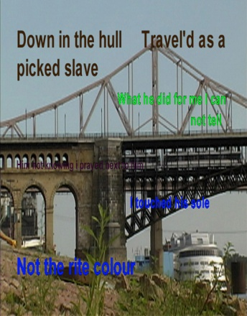
Wright color I note
Down in the hull
Travel’d as a picked slave
Fight’n to prey with me
What he did for me I can not tell
Him not knowing
I prayed next to him
Grateful to be held
I finally touched his sole
I am NOT the rite colour
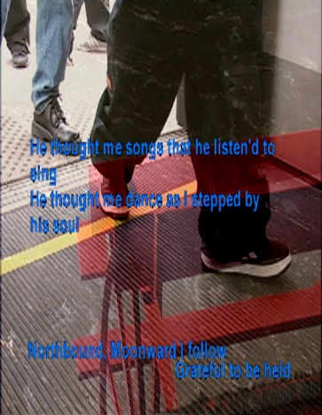
Where did my husband go
He never new I prayed to see him
He thought me songs that he listen’d to sing
He thought me dance as I stepped by his soul
I note the wright couleour

Where is my husband?
He weights for me in his paradise blue
Once there
Dead in the nets the ships clutch
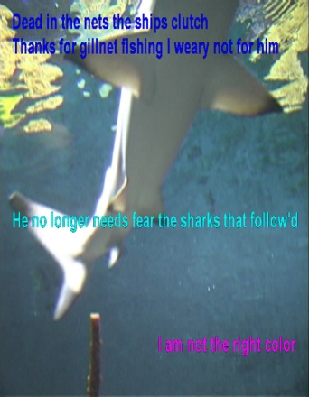
Thanks for gillnet fishing I weary not for him
He no longer needs fear the sharks that follow’d
I am not the right color.
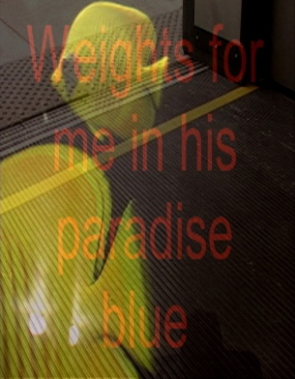
Wait in’ for him
He weights for me
Kingdom of white bones
Is his the home for me?
I meet his brother who’s my brother too
IN the hull We sleep together
I rememoried it was him
He was taken away
Separated by colour again
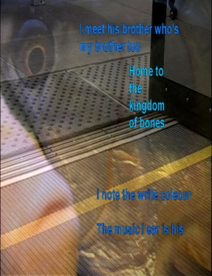
I’m not the right color
