Toby Huddlestone
AUP Proposal

Phobos self-degradation – the artist sends a form of self-degrading archival document to the Mars moon Phobos.

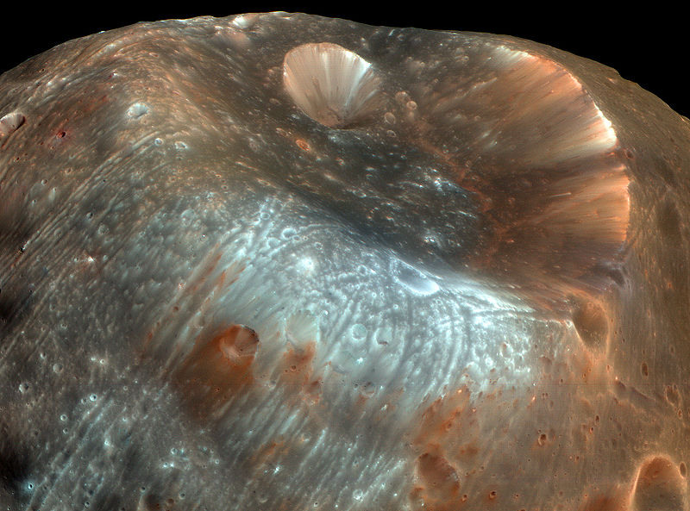
Stickney crater, Phobos. Imaged by Mars Reconnaissance Orbiter, March 23, 2008.

Place
Phobos, the largest of Mars' two moons, and the one closest to Earth is strongly believed (by the Scientific community) to be the current logical place in which we could potentially develop a human community in the near future, due to it being a cheaper place to reach than even our own moon, due to Phobos' relatively weak gravitational field. This was announced in New Scientist back in January 2010:

'PHOBOS is a name you are going to hear a lot in the coming years. It may be little more than an asteroid - just two-billionths of the mass of our planet, with no atmosphere and hardly any gravity - yet the largest of Mars's two moons is poised to become our next outpost in space, our second home.
Although our own moon is enticingly close, its gravity means that relatively large rockets are needed to get astronauts to and from the surface. The same goes for Mars, making it expensive to launch missions there too - perhaps even prohibitively expensive if President Obama's review of NASA's human space exploration policy is to be believed.'

Whilst performing a Wikipedia search on Phobos, I came across the prediction that Phobos is orbiting continually closer to Mars, which will result one day in it being 'smashed into smithereens':

'Phobos is 'a small, irregularly shaped object, Phobos orbits about 9,377 km (5,827 mi) from the center of Mars, closer to its primary than any other known planetary moon. Phobos is one of the least-reflective bodies in the solar system, and features a large impact crater, Stickney crater. It orbits so close to the planet that it moves around Mars faster than Mars itself rotates. As a result, from the surface of Mars it appears to rise in the west, move rapidly across the sky (in 4 h 15 min or less) and set in the east. Due to its short orbital period and tidal interactions, Phobos's orbital radius is decreasing and it will eventually either impact the surface of Mars or break up into a planetary ring.'

I like the scientific failure in all this, to announce Internationally (through New Scientist) that we are looking at Phobos as a potential place to further continue the chronology of the human race, only then to find out that it would ultimately lead to the inevitable; we will become extinct at some point and there is no stopping this, even if we last 'til the end of the Universe!

Art I believe places itself (and begins) in such failure, and is interested in all of this in order to attempt a making sense of things.

Files / the digital / science fiction
We are currently using hardware and software that is untested in accordance with how long they will last. The digital file types we use ever more frequently, and therefore become to rely on, could fail us at any point, leaving us with a potential (existential) 'nothing' - maybe just zeros rather than 'ones and zeros'.

I'm interesting in working with a University/Academic department in order to further research this phenomenon, and to attempt to develop a file type that is designed to degrade at the same rate as Phobos will take to impact Mars, therefore creating a symbiotic and utopian end of humankind. This is currently estimated as 11 million years.
The physical destruction of the human race through the collision of Phobos and Mars, and the digital/religious/memory destruction through the self-degradating file-type.*

*This of course takes on the notion that the Earth will have long disappeared and what's left of the human race will be living on Phobos attempting to develop another place to exist longer, but I don't mind this - it's science fiction/myth - the stuff that artists are so good at!

Location / instinct
There is a natural monolith on Phobos that is estimated to be the 'size of a building', another Scientific blur. I would look to place the self-degrading file either under or in this monolith.
It is the only feature in an otherwise featureless land, and so intrigues us the most as is likely to give more clues on how it came to form, thus providing us knowledge (that classic human trait) of Phobos as a potential habitat.
We are drawn to this monolith like the apes in Kubrick's 2001: A Space Odysey.

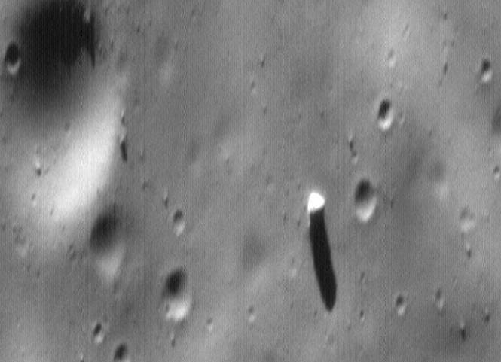
The Phobos Monolith (right of center) as taken by the Mars Global Surveyor (MOC Image 55103) in 1998. It is located near 15°N, 14°W, a few km east of Stickney crater.

This project is been researched further as and when I can. Maybe I'll just ask Richard Branson to fund it and then take me to Phobos.

Both images (copyright issues/infringement):
This file is in the public domain because it was created by NASA. NASA copyright policy states that "NASA material is not protected by copyright unless noted". (See Template:PD-USGov, NASA copyright policy page or JPL Image Use Policy.)

Stuart Clarke, New Scientist, 27.01.10
Wikipedia, 24.05.11

